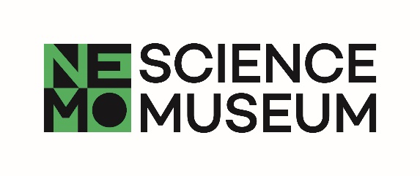

**SCIENCE LIVE**

**Take part in science**

**Would you like to know more?**

***Please do not share this information with other NEMO visitors, including family and friends that you are here with. Maybe they would like to take part in this study too and this information could influence the results.***

**Title of study:** How good are you at lying and detecting lies?

**Head scientist(s):** Prof. Dr. Theo Gevers, Prof. dr. Albert Ali Salah

**Researchers:** Dr. Sezer Karaoglu, Dr. Sophie van der Zee, Dr. Ronald Poppe

**University / Department**:University of Amsterdam – Informatics Institute, Utrecht University - Department of Information and Computing Sciences, Erasmus University Rotterdam - Erasmus School of Economics

**Dear participant,**

Thank you for taking part in this experiment. Now that you are finished, we would like to tell you a little more about what we are hoping to discover through this research.  
  
**What was the research about?**We know quite a lot about how people lie. But we don't understand precisely how age plays a role in how we lie and detect lies. Also, we don't know how familiarity facilitates lie detection. The experiment in which you've just participated is aimed at providing answers to these questions. In addition, we will use the recordings to teach computers how to spot small lies by focusing on facial expressions, body movement, voice and word use.

**Why is this research important?**We don't want people to lie to us. But we all frequently lie! Lying is part of how we communicate. Using small lies such as “I really like your T-shirt” and “I'm on my way” we ensure that we can get along just fine. Would you be able to be completely honest for one week? In short: we don't appreciate people lying to us, yet we lie. Apparently, we pick up the skill. But how and when? With your participation in our research, you've helped us to analyze how personality traits and age affect how you tell and spot lies, and whether you are better at detecting lies when you know someone well.

If you have questions about this study at a later time, please contact Ronald Poppe via [r.w.poppe@uu.nl](mailto:r.w.poppe@uu.nl).

Also, keep an eye on [www.nemosciencemuseum.nl/sciencelive](http://www.nemosciencemuseum.nl/sciencelive) for the results of this study and for announcements of future projects.